WEEK-11

Airline Ticket Booking UI using Modern Build Systems (Vite), Environment Configuration and Code Quality Tools.
An airline company wants a React-based web application where users can:
- Enter source and destination cities.
- Select a travel date.
- Book a flight ticket.
- Display booking confirmation.
The project should demonstrate:
- Modern Build System (Vite)
- Environment Configuration (.env)
- React Components and Hooks
- Code Quality Tools (ESLint)
- Controlled Forms
Project structure:
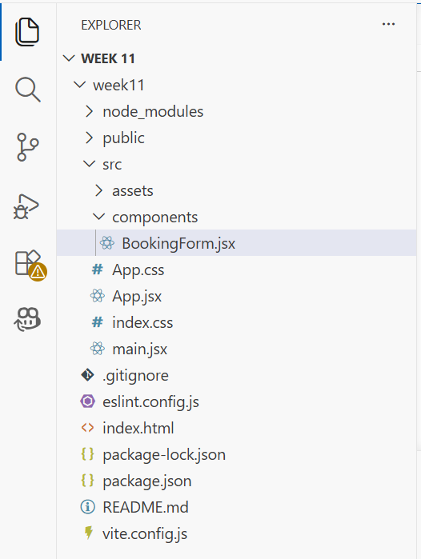

Modern Build System (Vite) :
Vite is a modern frontend build tool that provides:
- Faster startup
- Instant Hot Module Replacement (HMR)
- Optimized production builds
Environment Configuration (.env)
Environment variables store configuration values separately from code.
VITE_AIRLINE_NAME=SkyJet Airlines
BookingForm.jsx:.
import { useState } from "react";

function BookingForm() {

const [source, setSource] = useState("");
const [destination, setDestination] = useState("");
const [travelDate, setTravelDate] = useState("");
const [message, setMessage] = useState("");

const handleSubmit = (e) => {

e.preventDefault();

setMessage(
`Ticket Booked Successfully!
${source} → ${destination}
on ${travelDate}`
);

setSource("");
setDestination("");
setTravelDate("");
};

return (
<div>

<h2>Flight Booking</h2>

<form onSubmit={handleSubmit}>

<input
type="text"
placeholder="Source City"
value={source}
onChange={(e) =>
setSource(e.target.value)
}
required
/>

<br /><br />

<input
type="text"
placeholder="Destination City"
value={destination}
onChange={(e) =>
setDestination(e.target.value)
}
required
/>

<br /><br />

<input
type="date"
value={travelDate}
onChange={(e) =>
setTravelDate(e.target.value)
}
required
/>

<br /><br />

<button type="submit">
Book Ticket
</button>

</form>

<h3>{message}</h3>

</div>
);
}

export default BookingForm;
App.jsx:
import BookingForm from "./components/BookingForm";

function App() {

const airlineName =
import.meta.env.VITE_AIRLINE_NAME;

return (
<div>

<h1>{airlineName}</h1>

<BookingForm />

</div>
);
}

export default App;
App.css:
body {
text-align: center;
font-family: Arial, sans-serif;
}

input {
padding: 8px;
width: 250px;
}

button {
padding: 8px 15px;
}
Main.jsx:
import React from "react";
import ReactDOM from "react-dom/client";
import App from "./App";
import "./App.css";

ReactDOM.createRoot(
document.getElementById("root")
).render(
<React.StrictMode>
<App />
</React.StrictMode>
);
Output:
C:\Users\ADMIN\Desktop\Courses in KLH\FEDF 1st year\Week 11\week11>npm run dev
